Hotel Management User Manual Report

Introduction

**Course Title:** Enterprise Application Development

**Course** **Instructor:** Dr. Shuja-ur-Rehman Baig

**Student Name:** Sameer Jugno

**Roll Number:** BCSF21M048

Project Overview

Hotel Management is basically a Management website developed using ASP.NET Core(.NET 8).

Designed to provide a management system where Large Hotel Entities can use to Manage their Hotel.

Core Functionalities and Technologies

1. User Authentication

* User is authorized at the Signup/Login time to check whether he/she is a valid user.
* For Registered User there is Login page, and Signup page is for non-registered users.

1. Room Booking

* User can book a room and an event.
* User have to input his personal or payment credentials for booking.

1. Booking Validations

* Handle the booking dates like arrival date can’t be greater than departure date.
* In same way departure date can’t be before the arrival date.

1. Secure Payment Transaction

* Use Hashing to keep the user sensitive information saved from unauthorized persons.

1. Services for Users

* List the types of Services where the users can choose the type of service.

1. Cookies for auto form refill

* Use Cookies in the form to auto refill the user data. Instead of prompting the user input his information again and again.

Addition Enhancements

Clean Architecture

Clean Architecture is used to maintain the code files in a structured way.

Ajax

Use to dynamically change the specific part of the interface instead of loading the whole page.

Dockerizing

Dockerized the application for easier deployment in various environments.

Technologies Used

• Frontend: HTML, CSS, JavaScript, AJAX, Bootstrap for responsive design.

• Backend: ASP.NET Core MVC

• Database: Microsoft SQL Server with Entity Framework Core as the ORM.

• Real-Time Communication: SignalR for live updates and interactions.

• Deployment: Docker for containerization and IIS local server

Screenshots

Home Screen where user can Sign-in or check for events and rooms. User can also book a room and see upcoming events in Guest Guardian.

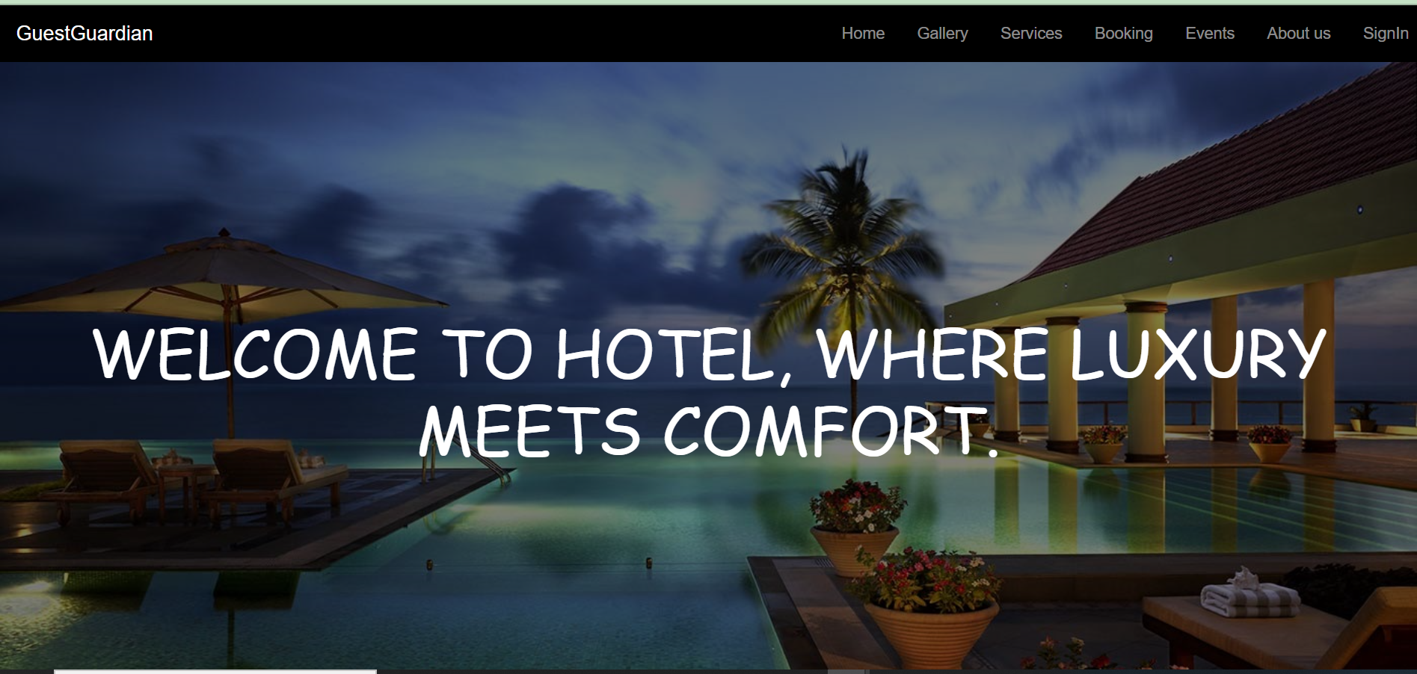

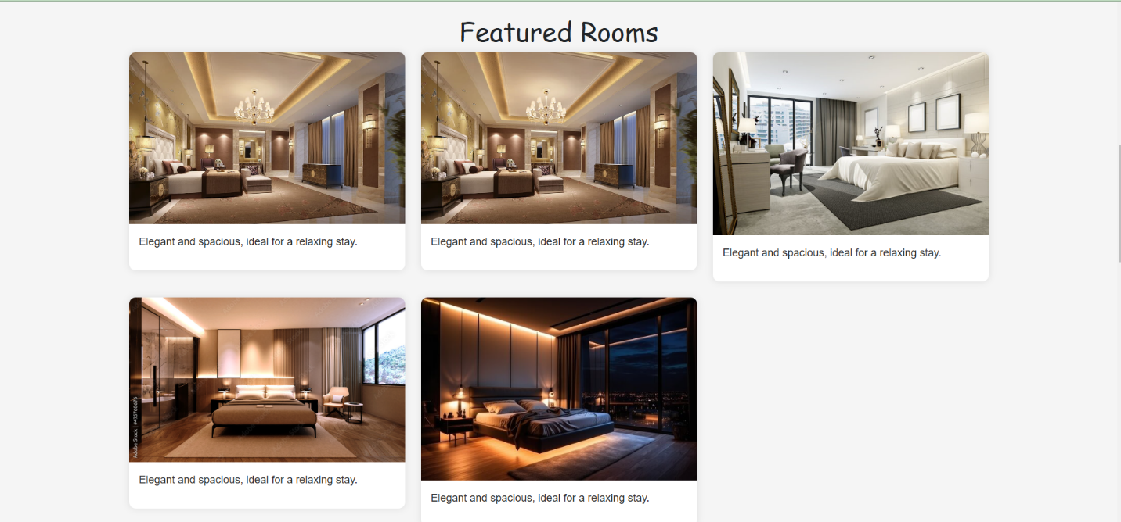Display Rooms just for the display purpose to showcase the types of room available at Guest Guardian.

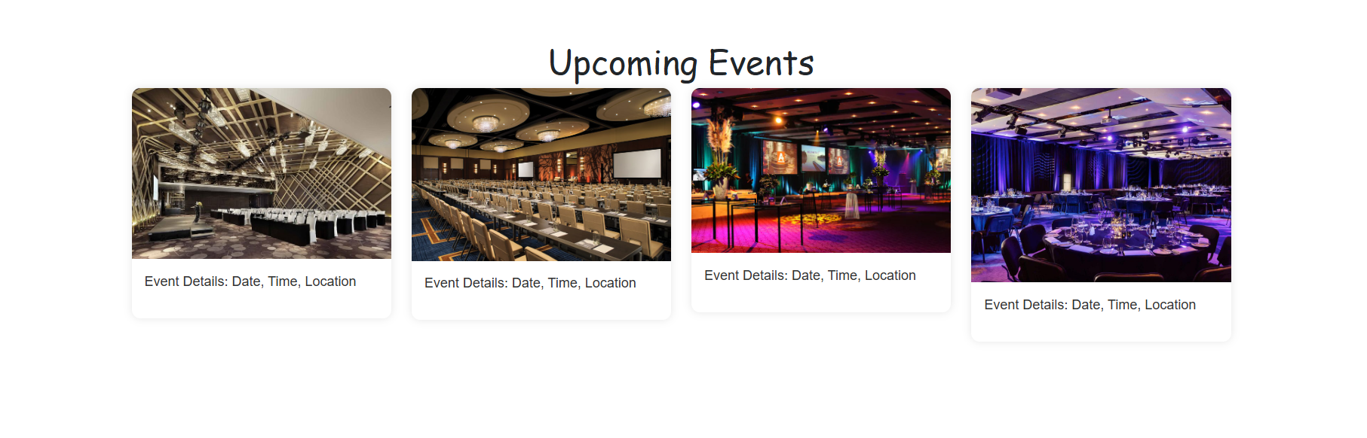

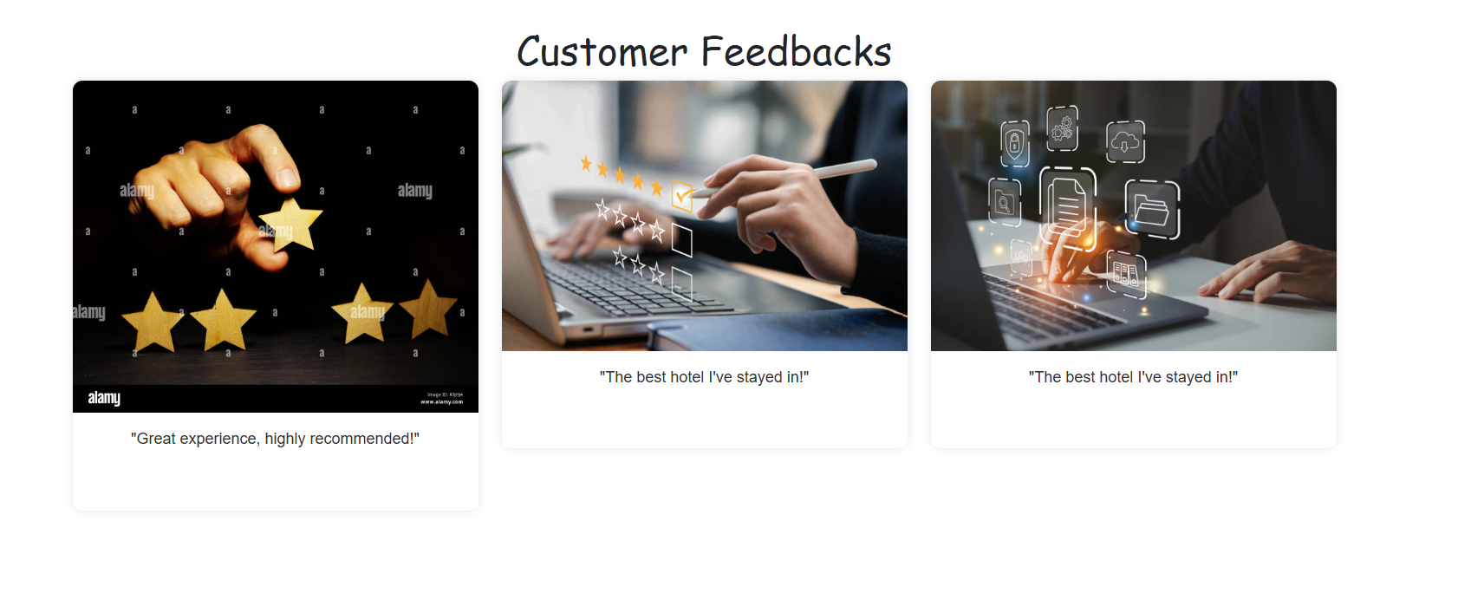

Footer Section Containing naviagations

